Traps (lobster or other species)

Vessels transit to the area, then drop or retrieve a trap, then move to the next location, and repeat.

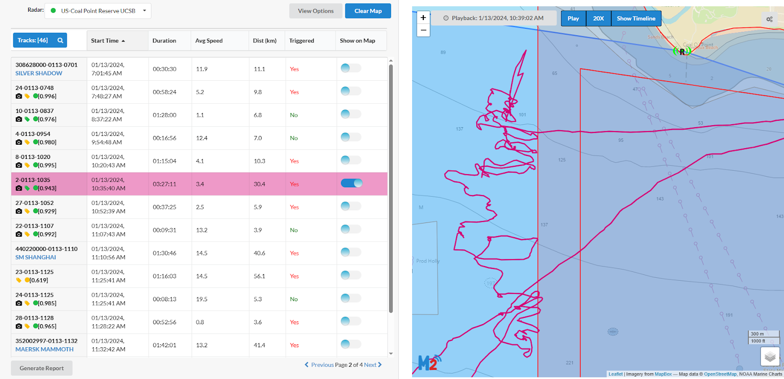

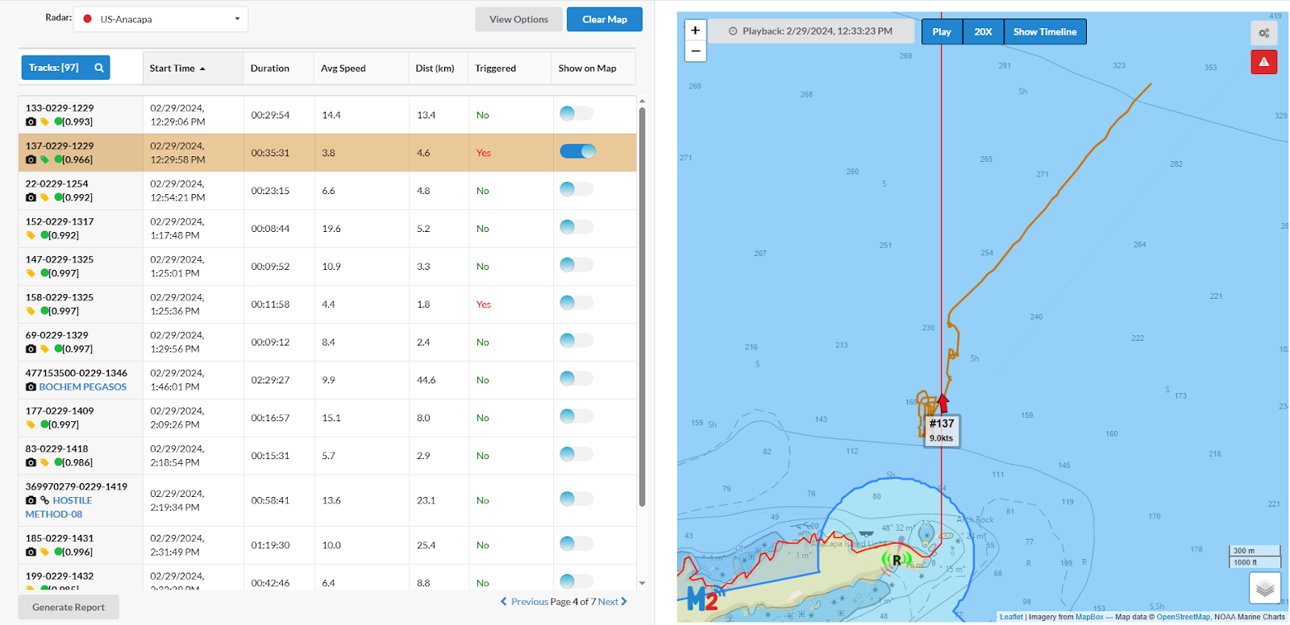

Trawler

Vessels drag nets through the water as they travel at slow, consistent speeds.

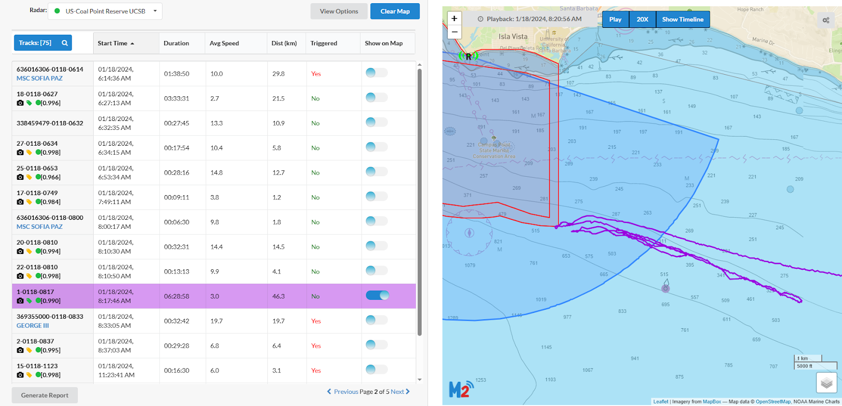

Purse seine

Nets are placed in the water in a circular pattern, and then pulled up by the vessel.

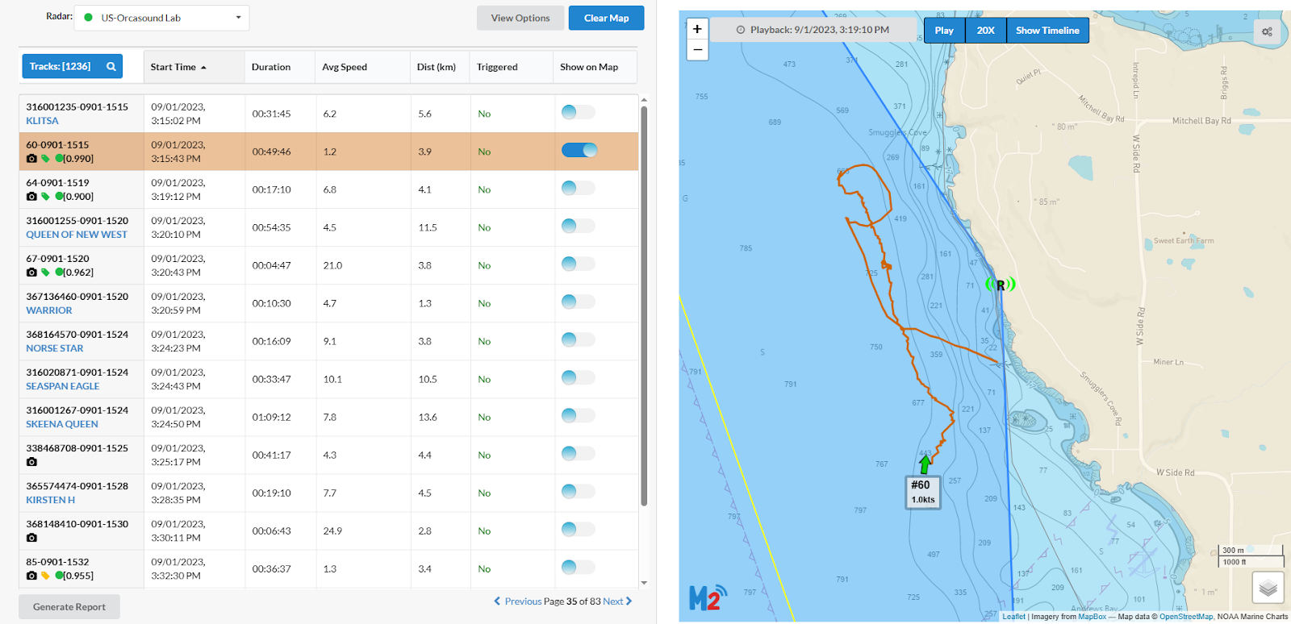

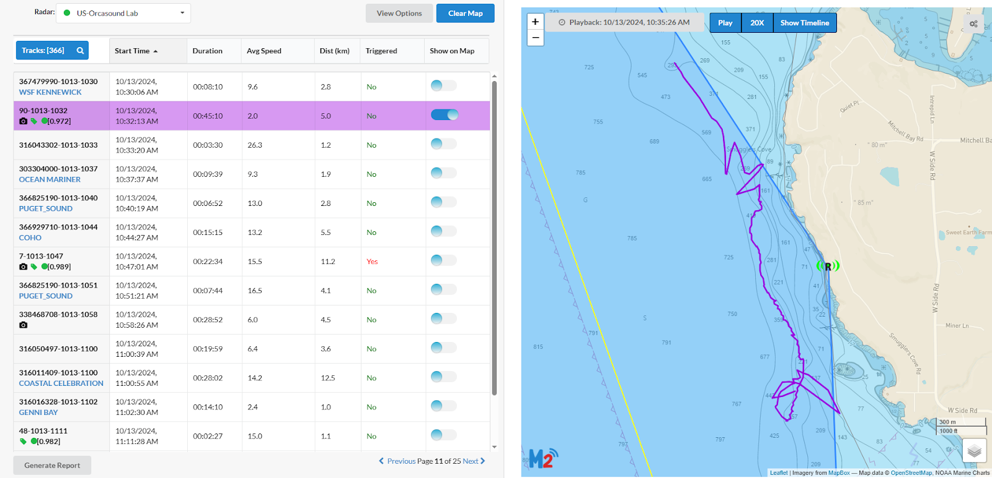

Hook and line

Vessels transit to the area, then drift or anchor while they fish over the side of the boat.

